Project Planning Phase
Project Planning Template (Product Backlog, Sprint Planning, Stories & Story Points)
Date | September 2026
Project Name | ServiceNow-Based Employee Laptop Request Application

Product Backlog, Sprint Schedule, and Estimation
The project is planned using Agile sprints. The backlog focuses on a guided ServiceNow laptop request, approval workflow, status visibility, notifications, asset availability, and fulfilment tracking.
Sprint | Functional Requirement (Epic) | User Story | User Story / Task | Story Points | Priority
Sprint-1 | Request & Eligibility (Epic 1) | USN-1 | Submit laptop request with guided form and required details | 3 | High
Sprint-1 | Request & Eligibility (Epic 1) | USN-2 | Validate employee eligibility and request information | 2 | High
Sprint-1 | Approval Workflow (Epic 2) | USN-3 | Route request to required approver(s) | 3 | High
Sprint-1 | Approval Workflow (Epic 2) | USN-4 | Approve or reject request with comments | 2 | High
Sprint-1 | Status Tracking (Epic 3) | USN-5 | View request status and approval stage in My Requests | 3 | High
Sprint-2 | Notifications (Epic 4) | USN-6 | Send email/ServiceNow notifications for status changes | 2 | Medium
Sprint-2 | Asset & Fulfilment (Epic 5) | USN-7 | Check laptop availability and allocate an available device | 3 | High
Sprint-2 | Asset & Fulfilment (Epic 5) | USN-8 | Update fulfilment, dispatch and delivery status | 3 | High
Sprint-2 | Dashboard & Reporting (Epic 6) | USN-9 | Provide IT dashboard for pending, approved and fulfilled requests | 3 | Medium
Sprint-2 | Security & Access (Epic 7) | USN-10 | Apply role-based access for employee, approver and IT teams | 2 | High
Sprint-2 | User Experience (Epic 8) | USN-11 | Show clear confirmation, next steps and expected timeline | 2 | Medium

Sprint totals: Sprint 1 = 13 Story Points | Sprint 2 = 15 Story Points | Total = 28 Story Points
Project Tracker, Velocity & Burndown

Sprint | Total Story Points | Duration | Sprint Start Date | Sprint End Date (Planned) | Story Points Completed | Sprint Release / Outcome
Sprint-1 | 13 | 10 Days | 17 Feb 2025 | 28 Feb 2025 | 13 | Request + approval workflow + status tracking
Sprint-2 | 15 | 10 Days | 03 Mar 2025 | 14 Mar 2025 | 15 | Notifications + asset fulfilment + dashboard + security

Velocity
Velocity = Total Story Points Completed ÷ Number of Sprints
Velocity = (13 + 15) ÷ 2 = 14 Story Points per Sprint
The planned average team velocity is 14 story points per sprint.
Burndown Chart
The burndown chart shows the planned reduction of remaining work across the project sprint period. Story points are tracked as work is completed.
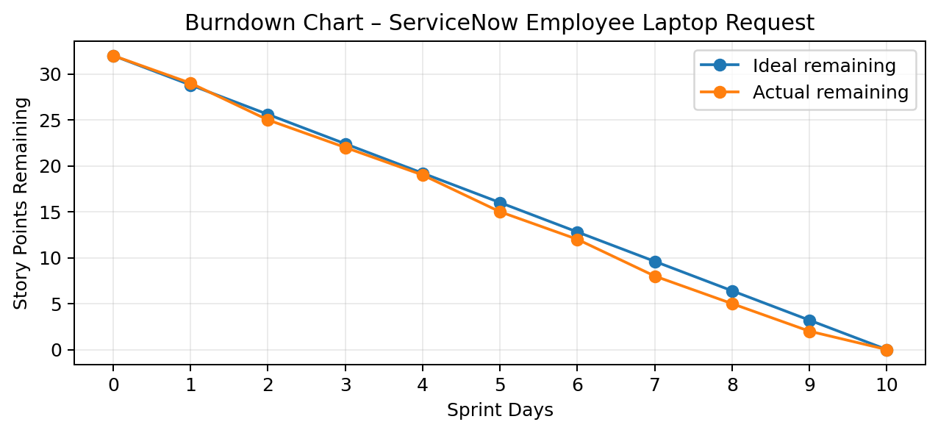

Project Planning Details
Sprint 1 – Request, Approval and Status
USN-1 – As an employee, I want to submit a laptop request through a guided ServiceNow form so that I can provide complete information.
USN-2 – As an employee, I want the system to validate my eligibility and request details so that incomplete requests are reduced.
USN-3 – As an approver, I want the request to be routed automatically so that I can review it without manual follow-ups.
USN-4 – As an approver, I want to approve or reject a request with comments so that the decision is transparent.
USN-5 – As an employee, I want to view my request and approval status so that I know what stage the request has reached.
Sprint 2 – Notifications, Fulfilment and Reporting
USN-6 – As an employee, I want notifications when my request changes status so that I do not need to follow up manually.
USN-7 – As an IT fulfiller, I want to check laptop availability and allocate a device so that approved requests can be fulfilled efficiently.
USN-8 – As an employee, I want delivery/fulfilment status updates so that I know when to expect the laptop.
USN-9 – As an IT manager, I want a dashboard of requests so that I can monitor workload, pending approvals and fulfilment.
USN-10 – As an administrator, I want role-based access so that users can only view or update information appropriate to their role.
USN-11 – As an employee, I want clear confirmation and next-step information so that the process is easy to understand.

Estimation Scale
Story Points | Effort Level | Meaning
1 | Very Easy | Small/simple change
2 | Normal | Straightforward task
3 | Moderate | Requires multiple steps/components
5 | Difficult | Complex or cross-functional work

References
ServiceNow – Employee service request and workflow concepts
ServiceNow – Request, approval and fulfilment workflow concepts
Agile/Scrum sprint planning, user stories and story-point estimation

